

Medical AI Agent to detect Heart diseases

**Miss Sarah Khaleel**

**Artificial Intelligence**

**National College of Business Administration & Economics**

**GROUP MEMBERS:**

1. Roma Irshad (2213003)
2. M. Tayyab Khan (2213233)
3. Agha Kazim Abbas (2213395)
4. Ismaeel Shahbaz (2233171)
5. Ayesha Rehan (2213377)
6. Maha Liaquat (2213274)
7. Amna Naveed (2213385)

**Medical AI Agent to Detect Diseases**

**Abstract**

**What is medical AI agent:**

Medical AI agent is an intelligent software system that leverages artificial intelligence (AI) techniques to assist in various healthcare-related tasks. These agents can perform tasks autonomously or collaboratively with humans, offering the potential to revolutionize the healthcare sector.

Here are some key aspects of medical AI agents:

* **Diagnosis and Medical Imaging:**

AI-powered algorithms can analyze medical images, such as X-rays, MRI scans, and CT scans, to detect abnormalities and assist in diagnosing various conditions.

For example, AI agents have shown promising results in detecting cancer at early stages, potentially improving patient outcomes and survival rates.

* **Automation and Efficiency:**

Medical AI agents can automate routine tasks, such as appointment scheduling, prescription refills, and answering common patient queries.

By handling repetitive processes, they free up healthcare professionals’ time, allowing them to focus on more complex and critical aspects of patient care.

* **Language and Multilingual Support:**

These agents can communicate with patients through various channels, including phone, chat, and messaging apps.

They are fluent in multiple languages, making it easier to provide personalized support to diverse patient populations.

* **Privacy and Compliance:**

Medical AI agents adhere to privacy regulations (such as HIPAA and GDPR) and maintain patient confidentiality.

Deployment options include on-premises, private cloud, or public cloud, ensuring secure and compliant self-service experiences.

In summary, medical AI agents combine human expertise with AI capabilities to enhance patient experiences, streamline processes, and improve healthcare outcomes.

**Medical AI Agent to Detect Heart Diseases:**

Following are the heart diseases which my AI agent can detect:

1. Congestive Heart Failure
2. Myocardial Infarction
3. Pulmonary Edema
4. Left Ventricular Failure
5. Rheumatic Fever
6. Hypertrophic Cardiomyopathy
7. Atrial Fibrillation
8. Endocarditis

**Congestive Heart Failure**

**What is Congestive Heart Failure?**

Congestive heart failure, also known as heart failure, is a long-term condition in which the heart is unable to pump blood effectively to meet the body’s needs.

**Causes of disease:**

* Coronary artery disease and/or heart attack.
* Cardiomyopathy (genetic or viral damage to heart muscle).
* Congenital heart disease (heart issues present at birth).
* Diabetes.
* High blood pressure (hypertension).
* Arrhythmia.
* Kidney disease.
* Obesity (body mass index higher than 30).
* Tobacco and recreational drug use.
* Certain medications, including cancer drugs (chemotherapy).

**Symptoms of disease:**

Shortness of breath: You may experience difficulty breathing, especially during physical activity or while lying down.

* Waking up short of breath at night: This can be a common symptom.
* Chest pain.
* Heart palpitations.
* Fatigue during activity.
* Swelling in the ankles, legs, and abdomen.
* Weight gain.
* Frequent urination at night.
* Dry, hacking cough.
* A full or hard stomach.
* Loss of appetite or upset stomach (nausea).

**Cure of disease:**

There are several approaches to manage it and improve quality of life. Here are some treatment options:

**Medications:**

1. **Angiotensin-Converting Enzyme (ACE) Inhibitors:** These drugs (such as benazepril, captopril, and enalapril) help dilate blood vessels, reduce blood pressure, and improve heart function.
2. **Beta Blockers:** Medications like acebutolol, atenolol, and bisoprolol slow down the heart rate, reduce blood pressure, and enhance heart function.
3. **Diuretics:** Diuretics (such as metolazone, indapamide, and hydrochlorothiazide) help remove excess fluid from the body, reducing swelling.
4. **Sodium-Glucose Cotransporter-2 (SGLT2) Inhibitors:** These newer drugs (such as dapagliflozin and empagliflozin) have shown benefits in heart failure management.

**Procedures and Devices:**

1. **Coronary Artery Bypass Graft (CABG):** In cases of blocked coronary arteries, surgeons use arteries from other areas of the body to restore blood flow.
2. **Heart Valve Surgery:** Damaged heart valves can be repaired or replaced.
3. **Implantable Left Ventricular Assist Device (LVAD):** A mechanical pump-like device is surgically inserted into the left ventricle to assist with pumping blood.
4. **Heart Transplant:** Reserved for extreme cases when other treatments fail2.

**Lifestyle Modifications:**

1. **Diet:** Adopt a heart-healthy diet rich in fruits, vegetables, whole grains, and lean proteins. Limit salt intake and avoid fatty foods.
2. **Fluid Restriction:** Monitor fluid intake to prevent excessive accumulation.
3. **Exercise:** Engage in regular physical activity as recommended by your healthcare provider.
4. **Quit Smoking:** Smoking worsens heart failure.
5. **Limit Alcohol:** Excessive alcohol can strain the heart.
6. **Weight Management:** Maintain a healthy weight to reduce stress on the heart.

**Myocardial Infarction**

**What is Myocardial Infarction?**

A myocardial infarction (MI), commonly known as a heart attack, occurs when blood flow decreases or stops in one of the coronary arteries of the heart, leading to tissue death (infarction) in the heart muscle.

**Causes of disease:**

The most common symptom is retrosternal chest pain or discomfort that typically radiates to the left shoulder, arm, or jaw. Other symptoms may include shortness of breath, nausea, feeling faint, cold sweat, tiredness, and a decreased level of consciousness. It’s important to note that about 30% of people experience atypical symptoms.

**Symptoms of disease:**

1. **Chest pain:** It may feel like pressure, tightness, pain, squeezing, or aching in the chest region.
2. **Radiating pain:** The discomfort can spread to the shoulder, arm, back, neck, jaw, teeth, or sometimes the upper belly.
3. **Cold sweat:** You might experience excessive sweating.
4. **Fatigue:** Feeling unusually tired or weak.
5. **Heartburn or indigestion:** Sometimes, heart attack symptoms can be mistaken for indigestion.

Lightheadedness or sudden dizziness.

Nausea.

Shortness of breath.

**Cure of disease:**

Immediate treatment is crucial. Options include percutaneous coronary intervention, which involves opening the blocked artery, and thrombolysis (clot-busting medications). Medications like aspirin, nitroglycerin, and heparin are also used.

**Pulmonary Edema**

**What is Pulmonary Edma?**

Pulmonary edema, also known as pulmonary congestion, is a condition characterized by excessive fluid accumulation in the lung tissue or air spaces (usually alveoli). This accumulation impairs gas exchange, leading to symptoms Sudden (Acute) Pulmonary Edema, Long-Term (Chronic) Pulmonary Edema and

High-Altitude Pulmonary Edema (HAPE) etc.

**Causes of disease:**

The causes of pulmonary edema can vary, and they depend on the type of edema. Here are some common causes:

* **Cardiogenic Pulmonary Edema:**

**Heart Failure:** The most common cause of pulmonary edema is heart failure. When the heart’s main chamber becomes too weak or stiff to pump blood effectively, it leads to high pressure in the lung’s blood vessels. This increased pressure causes fluid to leak into the lung tissue.

Other heart-related causes include cardiomyopathy, severe hypertension, coronary heart disease, and heart valve disease.

* **Non-Cardiogenic Pulmonary Edema:**

1. **Acute Respiratory Distress Syndrome (ARDS):** Inflammation of lung tissue due to toxins or injury can lead to non-cardiogenic pulmonary edema.
2. **Pulmonary Embolism:** A blood clot that lodges in the lung arteries can cause fluid accumulation.
3. **Organ Failure:** Heart, kidney, or lung failure can contribute to pulmonary edema.
4. **Lung Injury:** Trauma or damage to lung tissue.
5. **Neurogenic Pulmonary Edema:** Associated with neurological conditions.
6. **High Altitude Pulmonary Edema (HAPE):** Occurs at high elevations during travel or exercise.
7. **Infections:** Viral infections (such as dengue), pneumonia, and sepsis.
8. **Drug Overdose:**
9. Certain drugs like heroin or methadone can lead to pulmonary edema.

**Symptoms of disease:**

Here are the common symptoms associated with different forms of pulmonary edema:

* **Sudden (Acute) Pulmonary Edema:**

Difficulty breathing (dyspnea) or extreme shortness of breath that worsens with activity or when lying down.

A feeling of suffocating or drowning that intensifies when lying down.

Coughing up frothy sputum that may contain blood.

Rapid, irregular heartbeat (palpitations).

Anxiety, restlessness, or a sense of impending doom.

Cold, clammy skin.

Wheezing or gasping for breath.

* **Long-Term (Chronic) Pulmonary Edema:**

Awakening at night with a cough or breathlessness that may improve when sitting up.

Difficulty breathing during physical activity or when lying flat.

Fatigue.

Increased shortness of breath during physical exertion.

New or worsening cough.

Rapid weight gain.

Swelling in the legs and feet.

* **High-Altitude Pulmonary Edema (HAPE):**

HAPE occurs in individuals who travel to or exercise at high altitudes.

Headache (often the first symptom).

Shortness of breath during activity, which progresses to rest.

Initially, a dry cough, followed by frothy sputum (sometimes pink or blood-tinged).

Very fast heartbeat (tachycardia).

Weakness and chest pain.

**Cure of disease:**

Treatment for pulmonary edema depends on the underlying cause and severity. Here are some approaches:

**Medications:**

1. **Diuretics:** These medications (such as furosemide and spironolactone) help reduce fluid accumulation by promoting urine production.
2. **Vasodilators:** Drugs like nitroprusside and morphine dilate blood vessels, reducing pressure on the heart’s left ventricle.
3. **Calcium Channel Blockers:** Nifedipine is recommended for high-altitude pulmonary edema.

**Procedures:**

1. **Tracheal Intubation:** Facilitates ventilation.
2. **Suction Catheterization:** Removes excess fluids.

**Therapies:**

1. **Hyperbaric Oxygen Therapy:** Used for high-altitude pulmonary edema.
2. **Healthy Diet:** Focus on fruits, whole grains, and vegetables. Avoid foods high in salt content.

**Left Ventricular Failure**

**What is Left Ventricular Failure?**

Left-sided heart failure, also known as left ventricular failure, occurs when the left side of the heart is unable to function properly.

**Causes of disease:**

* **Coronary artery disease:** Narrowing or blockage of the coronary arteries can reduce blood flow to the heart muscle.
* **Heart attack:** Damage to the heart muscle due to a blocked artery can lead to heart failure.
* High blood pressure (hypertension): Prolonged high blood pressure strains the heart.
* **Valvular heart disease:** Malfunctioning heart valves affect blood flow.
* Abnormal heart rhythms.
* Infiltrative diseases (such as amyloidosis and sarcoidosis).
* Other risk factors include diabetes, obesity, sleep apnea, older age, smoking, and exposure to certain toxins or medications

**Symptoms of disease:**

* Initially, symptoms may be mild or mistaken for a cold or allergy.
* As heart function worsens, you may experience:
* Constant coughing.
* Shortness of breath with activity or when bending over.
* Waking up short of breath or unable to lie flat at night.
* Weight gain.
* Swelling (edema) in ankles, legs, or abdomen.

**Cure of disease:**

* While there is no cure for left-sided heart failure, it is treatable.
* Treatment measures include medications and heart-healthy lifestyle changes to reduce pressure on the heart.
* Addressing underlying conditions (such as hypertension or coronary artery disease) is crucial.
* Regular medical follow-up and adherence to treatment recommendations are essential for managing heart failure

**Rheumatic Fever:**

**What is Rheumatic Fever?**

Rheumatic fever is an autoimmune condition that inflames tissues, including joints and the heart. It typically occurs as a complication of untreated strep throat or scarlet fever infections caused by group A Streptococcus bacterium.

**Causes of disease:**

Rheumatic fever occurs after an infection with group A streptococcus triggers an immune reaction, leading to the condition.

It usually affects children aged 5 to 15 years but can occur at any age.

Risk factors include family history, certain inherited genes, the type of streptococcal infection, and environmental factors like overcrowding and poor sanitation.

**Symptoms of disease:**

* Red, jagged rash: One common symptom is a rash that may be flat and red with irregular edges.
* Other symptoms can vary depending on which part of the body is affected:
* Painful and tender joints
* Chest pain
* Fatigue
* Fast heart rate
* Palpitations
* Inflammation of multiple joints

**Cure of disease:**

* **Antibiotics:** To clear the streptococcal bacteria and prevent recurrences.
* **Anti-inflammatory medications:** Such as aspirin, ibuprofen, or corticosteroids to manage symptoms.

**Hypertrophic Cardiomyopathy**

**What is Hypertrophic Cardiomyopathy?**

Hypertrophic cardiomyopathy (HCM) is a condition where the heart muscle becomes thickened (hypertrophied), making it harder for the heart to pump blood effectively.

**Causes of disease:**

HCM is usually caused by genetic changes that lead to thickening of the heart muscle.

It typically affects the septum, which is the wall between the two bottom chambers of the heart (ventricles).

There are two types:

* **Obstructive hypertrophic cardiomyopathy:** The thickened wall obstructs blood flow out of the heart.
* **Nonobstructive hypertrophic cardiomyopathy:** The left ventricle (the main pumping chamber) stiffens, reducing the amount of blood it can hold and pump.

Heart muscle cells are also arranged differently in people with HCM, which can trigger irregular heartbeats.

**Symptoms of disease:**

* Chest pain, especially during exercise.
* Fainting, especially during or just after physical activity.
* Sensation of fast, fluttering, or pounding heartbeats (palpitations).
* Shortness of breath, particularly during exercise.

**Cure of disease:**

While there is no direct cure for hypertrophic cardiomyopathy (HCM), the focus is on managing symptoms, reducing complications, and improving quality of life. Here are some approaches:

**Medications:**

Medicines can help reduce how strongly the heart muscle squeezes and slow the heart rate, allowing the heart to pump blood more effectively.

Common medications used to treat hypertrophic cardiomyopathy and its symptoms include:

1. **Beta blockers (such as metoprolol, propranolol, or atenolol):** These help relax the heart muscle and regulate heartbeats.
2. **Calcium channel blockers (such as verapamil or diltiazem):** These also help with heart muscle relaxation and rhythm control.

**Atrial Fibrillation:**

**What is atrial fibrillation?**

Atrial fibrillation (also known as Afib or AF) is an irregular heart rhythm (arrhythmia) that originates in the upper chambers of the heart (atria).

**Causes of disease:**

* High blood pressure
* Coronary artery disease
* Obesity
* Thyroid disorders
* Stress
* Alcohol consumption
* Metabolic disorders
* Heart valve abnormalities
* Genetic factors

**Symptoms of disease:**

* Some people with Afib may have no symptoms, especially if their ventricles are beating at a normal or slightly elevated pace.
* However, when ventricular rates increase, symptoms may include:
* Extreme fatigue
* Irregular heartbeat
* Heart palpitations
* Feeling like there are butterflies or a fish flopping in the chest.

**Cure of disease**:

* Medications (such as anti-arrhythmic drugs and anticoagulants).
* Procedures (such as electrical cardioversion, catheter ablation, and atrioventricular node ablation).
* Lifestyle modifications (including diet, exercise, and stress management).

**Endocarditis**

**What is endocarditis?**

Endocarditis is an inflammatory condition that affects the inner lining of the heart chambers and valves.

**Causes of disease:**

Bacterial infection is the primary cause.

**Symptoms of disease:**

* Fever above 100°F (38.4°C).
* Sweats or chills, especially night sweats.
* Skin rash.
* Pain, tenderness, redness, or swelling.
* Wounds or cuts that won’t heal.
* Red, warm, or draining sores.
* Sore throat, scratchy throat, or pain when swallowing Fever above 100°F (38.4°C).
* Sweats or chills, especially night sweats.
* Skin rash.
* Pain, tenderness, redness, or swelling.
* Wounds or cuts that won’t heal.
* Red, warm, or draining sores.
* Sore throat, scratchy throat, or pain when swallowing

**Cure of disease:**

1. **Antibiotics:** High doses of antibiotics are used to treat bacterial endocarditis.
2. **Hospitalization:** You’ll generally spend a week or more in the hospital to monitor treatment effectiveness.
3. **Surgery:** Sometimes necessary to repair or replace damaged heart tissue.

**Screen Shot:**

**Source code:**

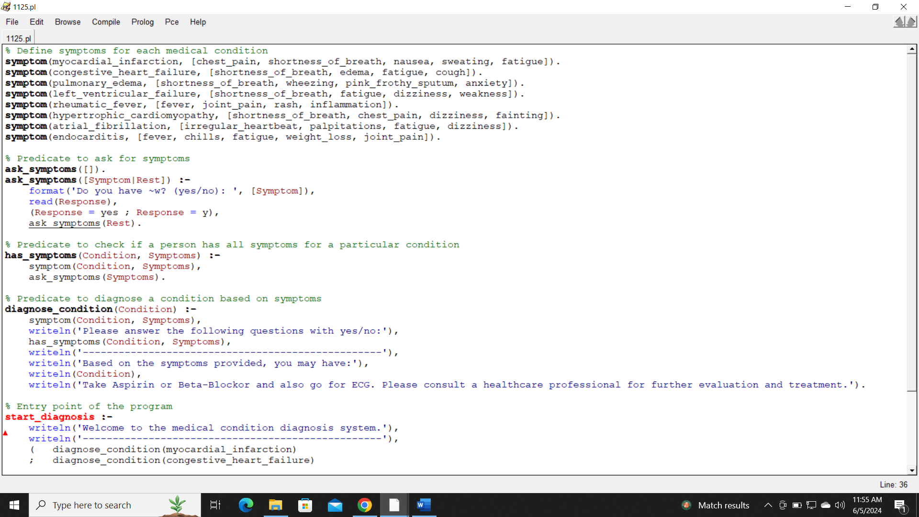

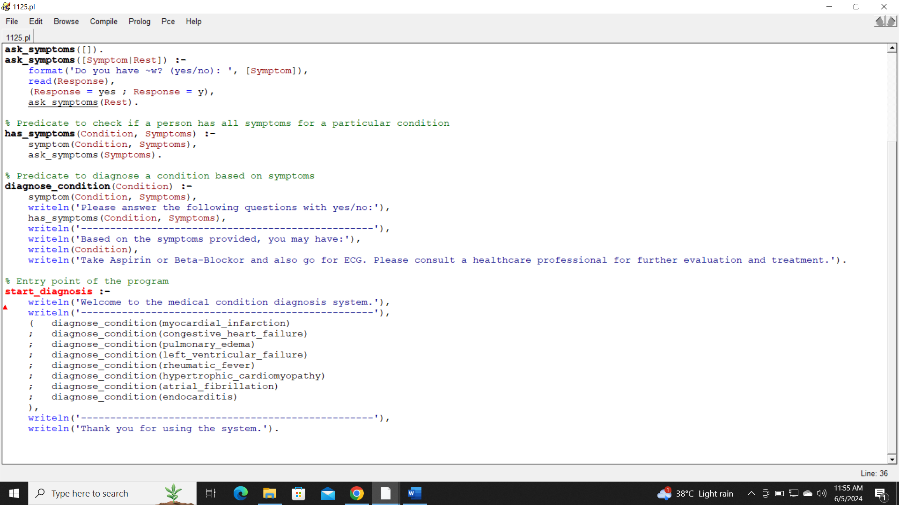

**Object Code:**

